Read the following E-Book

URL - <https://books.google.com/books?id=lB4PAwAAQBAJ&pg=PA96&lpg=PA96&dq=8088+intel+video&source=bl&ots=3UPUUM04eP&sig=Hgwo4DC1Zujf9iVlzz01uMGaoFc&hl=en&sa=X&ved=0ahUKEwjk5ujfpLDPAhUE7GMKHb0vBwwQ6AEITjAH#v=onepage&q=8088%20intel%20video&f=false>

Pages 42 – 55

Here is page 42

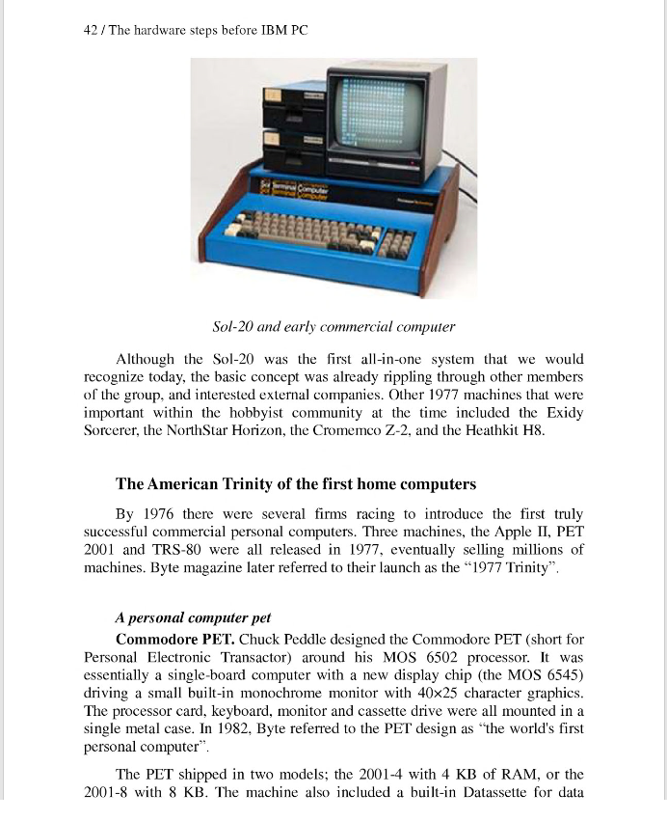

Here is page 55

